Lesson 7. Firebase Overview and Data

Aim: What are the features and limitations of Firebase and how do we use Firebase data?

Objectives: After the lesson, students should be able to:
- Obtain basic understanding on Firebase

References:
https://firebase.google.com/docs/

CLASS PROCEDURE:
Do Now:
Go to the Firebase dashboard, and log in using https://console.firebase.google.com/u/1/. Click “Add Project” to add a new project.

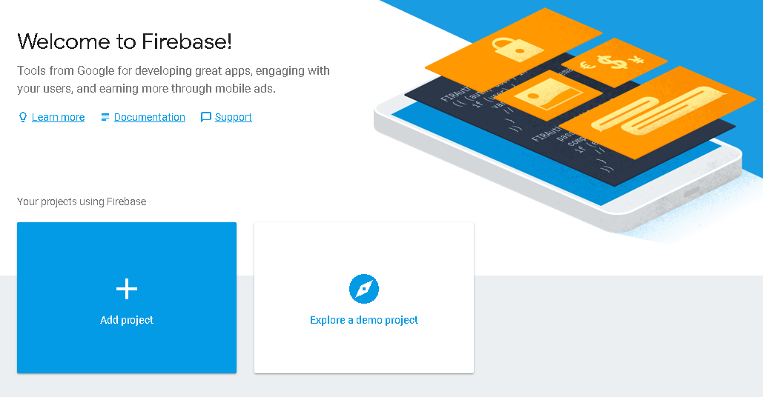
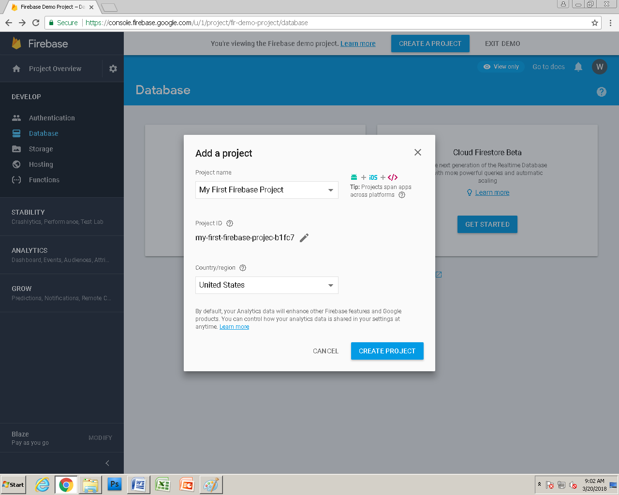
After the project is created, navigate to “Database”, and click on “Get Started”.

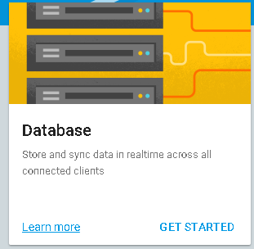

You will see two options – “Real – time database” and “Cloud Firestore Beta”. What are the difference between the two options? Research online and discuss with your partner.

Class Discussion / Presentation:
- What capacity does the Real – time Database provide?

- The Firebase Realtime Database lets you build rich, collaborative applications by allowing secure access to the database directly from client-side code. Data is persisted locally, and even while offline, realtime events continue to fire, giving the end user a responsive experience. When the device regains connection, the Realtime Database synchronizes the local data changes with the remote updates that occurred while the client was offline, merging any conflicts automatically.
- The Realtime Database provides a flexible, expression-based rules language, called Firebase Realtime Database Security Rules, to define how your data should be structured and when data can be read from or written to. When integrated with Firebase Authentication, developers can define who has access to what data, and how they can access it.
- The Realtime Database is a NoSQL database and as such has different optimizations and functionality compared to a relational database. The Realtime Database API is designed to only allow operations that can be executed quickly. This enables you to build a great realtime experience that can serve millions of users without compromising on responsiveness. Because of this, it is important to think about how users need to access your data and then structure it accordingly.

- What rules shall we follow if we decide to use the Real – time database?
https://firebase.google.com/docs/database/security/quickstart

Configuring rules
You can find and change the rules for your database in the Firebase console. Simply choose your project, click on the Database section on the left, and then select the Rules tab. If you would like to test your security rules before putting them into production, you can simulate operations in the console using the Simulate button in the upper right of the rules editor.
You can also update your rules using our Command Line Interface. This is especially useful if you want to update your rules programmatically, such as from an automated deployment system.

Sample rules
By default, your database rules require Firebase Authentication and grant full read and write permissions only to authenticated users. The default rules ensure your database isn't accessible by just anyone before you get a chance to configure it. Once you're set up, you can customize your rules to your needs. Here are some common examples:

DEFAULT

PUBLIC

USER

PRIVATE
The default rules require Authentication. They allow full read and write access to authenticated users of your app. They are useful if you want data open to all users of your app but don't want it open to the world.
// These rules require authentication
{
"rules": {
".read": "auth != null",
".write": "auth != null"
}
}

Pair – sharing Activity #1:
Navigate to the “Real – time database” for the project you just created, and click on “+” to add data to your Firebase database.

- How can you add and remove data from the database?

- Go to https://adobe.github.io/Spry/samples/data_region/JSONDataSetSample.html, download one or two of the JSON files. How can you import the JSON file into the Firebase real – time database?
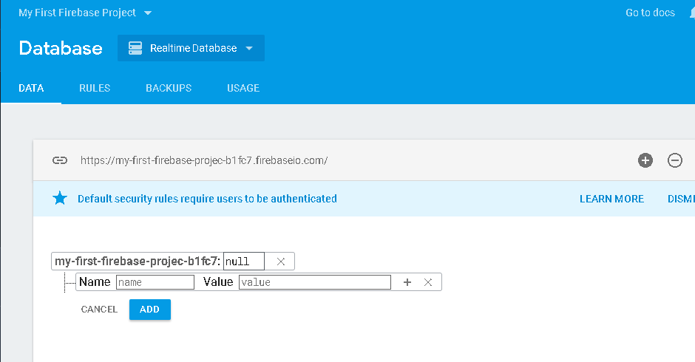

Work with your partner and find a way to import the Ngram corpus to a Firebase DB. You can use the Firebase online documents as a reference https://firebase.google.com/docs/guides/ or research online.

Pair – sharing Activity #2:

Work with your partner and continue working on the design for your N-Gram project. Due: April 10th.

